**INNOVATION AND IDEA**

A city is a complex system which consists of many interdependent subsystems where traffic system is one of its important subsystems. A study says; it is the cornerstone of the world’s economy . Moreover, it is also declared as one of the major dimensions of the smart city . With the rapid growth of the population of the world, the number of vehicles on roadways is increasing consequently, the rate of traffic jams is also increasing in the same manner . Traffic jams are not just wasting time but in some cases, it is witnessed that criminal activities like mobile snatching at traffic signals also happen in metropolitan cities . On the other hand, it is not only affecting ecosystem badly .but the efficiency of industries is also being affected . It is, therefore, identified that active traffic management is a necessity. In majority countries, traffic is managed through fixed time signals whereas, in large cities of some developed countries, traffic is managed through centrally controlled systems. The paradigm of the Internet of Thing (IoT) has been introduced in traffic management systems . To the best of our knowledge, it is identified that till date the current traffic management systems are centralized. In case of networking issues, such systems may crash. In addition, there is less focus on fluctuations in traffic flow. Therefore, the proposed system manages the traffic on local and centralized servers by exploiting the concepts of IoT and Artificial Intelligence together. The representation of traffic data in statistical form can also be helpful to authorities for real-time controlling and managing traffic. Moreover, it may also be helpful for future planning.

**PROJECT MODEL DESIGN**

The proposed system, shown in Figure 1, is designed to govern traffic at road networks, sensing through sensors, surveillance cameras, and RFIDs which are embedded on roadsides. The system works in a distributed manner, it processes sensors’ data at the node level and videos’ data at the local server, calculates cumulative density to regulate the traffic according to density. In addition to this, it also tackles emergency vehicles such as ambulance, fire brigade. it also helps the users to know the congestion status at a road through prediction. The system is divided into three layers. A) Data Acquisition and Collection layer. B) Data Processing and Decision-making layer C) Application and Actuation layer.

1. **Data Acquisition and Collection Layer**

Several ways of traffic detection have been used by the researchers in the state of the art which consists ultrasonic sensors, RFIDs, surveillance cameras and light beam. All these sources have merits as well as demerits; the suitable sources in the context of the proposed system are surveillance cameras, ultrasonic sensors, RFIDs, smoke sensors and flame sensors. A surveillance camera is the most widely used source to detect the road traffic in this field due to efficiency and ease of maintenance . Blob detection algorithm is applied to the video stream at the local server due to its performance and capability of noise reduction . After traffic detection, a local server sends the density measured through image processing to the respective microcontroller.

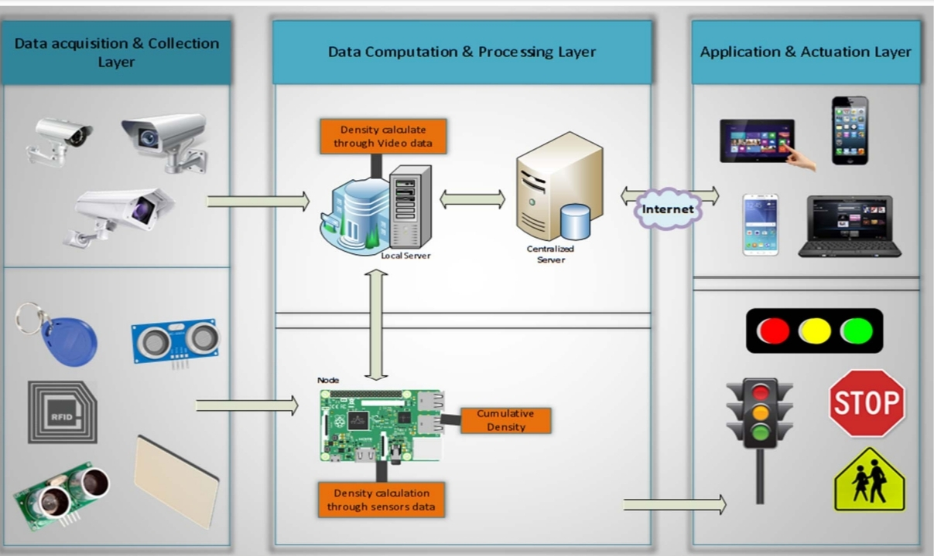

Apart from the cameras, this system is also using ultrasonic sensors to enhance the accuracy. Sensors are integral part used to detect traffic density in many traffic management system applications [13]. It measures distance by sending out a sound wave of a specific frequency and listening for that sound wave to bounce back. This economical sensor measures the distance 2 cm to 400 cm [19].

The system calculates the distance by using the following formula:

Distance = ((a x b) / 2)

a= Speed of sound

b= time taken

As shown in Figure 2, there are three pairs of sensors at a certain distance are embedded on each roadside of an intersection to calculate the traffic density. Each sensor’s reading is 1 or 0 (Either that particular sensor detects the vehicle or not). At the node side, density is calculated by considering the readings of all the sensors embedded at that particular roadside

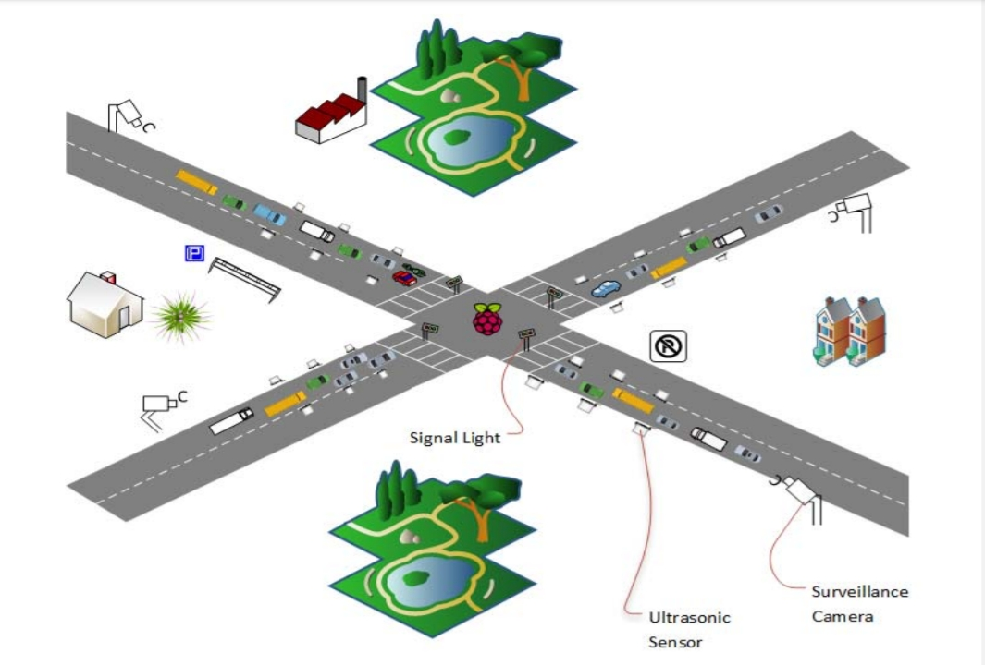

1ଵ = Pi + Pi+1 + Pi+2

P is the pair of ultrasonic sensors. Table 1. shows the states of

the sensors and their results are as follow:

TABLE 1. TRAFFIC DENSITY STATES BY ULTRASONIC SENSORS

|  |  |  |
| --- | --- | --- |
| Condition / Sensors | P1 P2 P3 | Status |
| Condition 1 | 1 0 0 | Low |
| Condition 2 | 1 1 0 | Medium |
| Condition 3 | 1 1 1 | High |

The microcontroller receives results from sensors and video from a local server to calculate cumulative density using Table 2.

CUMULATIVE DENSITY

|  |  |  |  |
| --- | --- | --- | --- |
| Situations | Sensors’ Result | Camera’s Result | Traffic Density |
| Situation 1 | High | High | High |
| Situation 2 | High | Medium | High |
| Situation 3 | High | Low | Medium |
| Situation 4 | Medium | High | High |
| Situation 5 | Medium | Medium | Medium |
| Situation 6 | Medium | Low | Medium |
| Situation 7 | Low | High | Medium |
| Situation 8 | Low | Medium | Medium |
| Situation 9 | Low | Low | Low |

**B. Data Processing and Decision-Making Layer**

The system manages the road traffic according to the traffic condition. a) In the first situation, each traffic signal has a preset time that is Į seconds, when there is normal traffic on road. Every signal is going for green at their turn for Į seconds, and rest of signals at that time remains red until all remaining traffic signal at an intersection complete their turn. Traffic ratio is increasing day by day and our current Fixed-time signal control system is not working well in this situation, there is a dire need to add a density based traffic management module which allocates time dynamically to each lane on the base of the traffic density, in second part of algorithm when the capacity of traffic is increased and flow of traffic is not in routine, the system calculates the level of density according to Table 2. and update the time ȕ of traffic signal on the basis of traffic density.

**Algorithm:**

Part(I) When no emergency vehicle detected

if (Traffic Density == high)

if (Rush Interval==Yes)

Time= ((Į ex

sinș) + ȕ) + Ȗ

else

Time = (Į ex sinș) + (cosș * Ȗ) + ȕ

else

if (Rush Interval==Yes)

Time= (Į ex sinș) + Ȗ

else

Time= Į

Part (II) When RFID tags detect emergency vehicle

While (vehicle Exits)

Time != 0

Where Į is regular prefixed time given to a specific roadside, ș=90, x=0, ȕ is extra time added in case of traffic congestion and Ȗ is extra time added when there is rush interval near to approach. Moreover, if the emergency vehicle is detected, the system stops its normal operation and immediately turns the respective signal green and it remains green until that particular vehicle passes to that intersection. In addition to this, if the fire is detected on the road, the microcontroller intimates to the respective local server through which it goes to the centralized server and then this information goes to the respective department through a mobile application. The flow, how the system calculates signal time

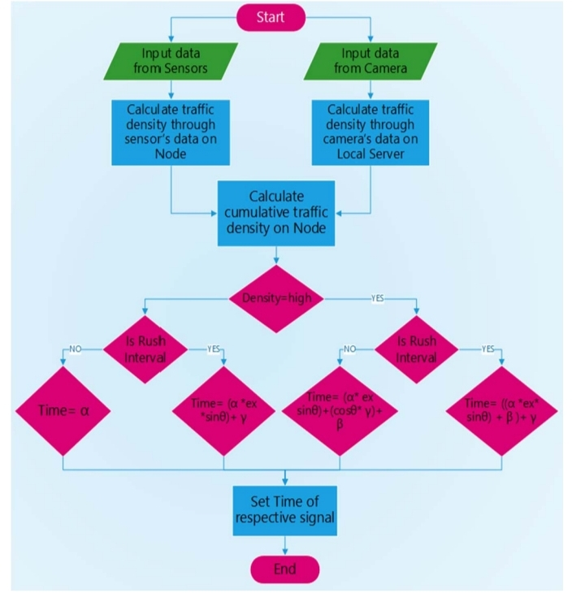

**C. Application and Actuation Layer**

In this layer, there are two types of information delivered i) duration of a green signal from node to traffic signal and ii) daily, weekly, monthly and yearly reports to the administration of smart traffic management system through the web application from a centralized server. First of all, the system calculates rush interval by using Regression Tree algorithm onthe data saved at the local server and updates this report to the centralized server on the daily basis (after 24 hours). The rush interval is the time span of thirty minutes. This report is then displayed on the web application which is linked to a centralized server which is for the administration of smart traffic management system, that shows daily, weekly, monthly and yearly graphs of rush intervals for roads. This graphical information is fruitful for the future road planning and resource management. Secondly in the actuation module, whenever the rush interval is identified, the local server intimates to the respective microcontroller along with the road id. After receiving the rush interval intimation, the decision-making module updates the duration of the green signal to the respective traffic signal. In this modern era, where time is money and wastage of time are not affordable, there is a need to know the traffic condition on the particular road prior to travel on that road by using mobile application. Moreover, this system is also capable of managing emergency situations like if the smoke and fire are detected on the road. In case of fire on the road, which is detected by flame sensors and extensive smoke through smoke sensors, the system intimates to the nearby relevant department through a mobile application for further actions.